**Spetial Microphone**

Introduction: This would be an Android based mobile application.

First Approach: At the primitive approach, there would be two cellphones. One would act as a microphone broadcaster. Another one would act as a speaker output.

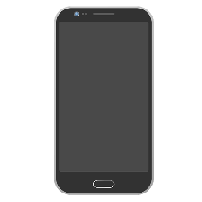 

Broadcaster Receiver

Microphone (BM) Speaker (RS)

Initially we will test with two android devices. When someone speaks at the BM side, the application would scan via Bluetooth/hotspot technology and automatically connect to the other device which would act as a speaker output. After the first test is successfully done, we would proceed with multiple devices on the Receiver Side side. In this case when someone speaks at Broadcaster Microphone side the application would scan for nearby devices and automatically connect to all of them simultaneously.

Second Approach: In this stage a device would take audio with noises from nearby sources and produce better sound quality as output in the other device. Initially it would be done with two devices. Usually modern cellphones have numerous microphones. So, we can assume that a device would take sound input from its microphones and broadcast the sound with better quality audio to a nearby device which would be automatically connected when bought into the range of the broadcasting device. After this approach is successfully done, we can try with numerous android devices which would take audio input simultaneously and broadcast to another android phone. Here the number of cellphones in the receiving side may vary with project progress.